**PARKING MANAGEMENT SYSTEM**

**PROJECT REPORT**

Submitted To:

**Ma’am SAHAR JUMANI**

Prepared By:

**AHSAN ABDUL WAHEED (CSC-18F-123)**

**HUZAIFA ARIF (CSC -18F-137)**

DEPARTMENT OF COMPUTER SCIENCE



**SINDH MADRESSATUL ISLAM UNIVERSITY**

**KARACHI (PAKISTAN)**

**ACKNOWLEDGEMENTS**

I sincerely thank my thesis adviser, “MISS SAHAR JUMANI”, for his guidance, unrelenting support, and assistance whenever I needed his help. Without his help it would have not been possible for me to accomplish this task.

**CERTIFICATE**

This is to certify that the project titled “Parking Management System”

Is the bona fide work carried out byAHSAN ABDUL WAHEED (CSC-18F-123)

, HUZAIFA ARIF (CSC -18F-137) students of BSCS , Sindh Madressatul Islam University

during the academic year 2020-21.

**Signature of the Guide**

**Date: 28-8-2020**

|  |  |  |
| --- | --- | --- |
| **S.No.** | **Table Of Content** |  |
| 1) | INTRODUCTION   1. Background 2. Statements Of problems 3. Aims and Objective 4. Scope of the Project 5. Limitations |  |
| 2) | LITERATURE REVIEW |  |
| 3) | PLANNING |  |
| 4) | SYSTEM REQUIREMENT  Software Requirement and Hardware Requirement |  |
| 5) | INTERFACE |  |
| 6) | PROJECT CODE |  |
| 7) | PROJECT SUMMARY |  |
| 8) | CONCLUSION |  |
| 9) | REFERENCES |  |

1. **INTRODUCTION:**

# BACKGROUND OF STUDY

Parking Management System deals with all kind of vehicle details, specially we can put car, bus and rikshaw. This project store nine vehicle at a time, give the record of all vehicle and also to evaluate the fee structure for every vehicles entry and exit.

Parking Management System for handling the incoming and outgoing vehicle data in a car park. It is simple for Admin to acquire the data if the vehicle has been accessed by amount that it may collect.

# STATEMENT OF PROBLEM

Now days in many public places such as malls, multiplex system, clinics , schools, business areas, vehicle parking is a critical issue. Parking area for cars has plenty of lanes / slots for parking. But one has to search at all the lanes to park a car. This often requires a great deal of hard labor, and spending. Instead of vehicles stuck in towing the vehicle will park with low cost on safe and stable. By parking the vehicle in public place the vehicle can be claimed by towing person but in this case there is no towing problems and no need to give fine for anything we can park our vehicle with securely.

# AIMS AND OBJECTIVES

## AIMS OF THE STUDY

To design a Parking Management System for storing vehicles records in a particular Parking Palace.

## OBJECTIVES OF THE STUDY

The goal of this project is to create a Vehicle Parking management system that allows the time management and monitoring of vehicles utilizing the identification of number plate. The system that monitors the arrival and departure of vehicles maintains a record of vehicles inside the parking lot and decides whether or not the parking lot is complete. Based on their time usage it can decide the expense of per car.

We can park our vehicle in our own slot by paying.

• Because of that there are no towing problems.

• And our vehicle has been parked as a secure condition.

• There is no risk for vehicle owner for parking the car.

• In case of any damages and problem of vehicle that will claim by parking management.

• As the world is facing many threads daily, robberies are done easily with no track to trace, bomb blasts occur with the use of vehicle, so if a proper system is adopted each and every record can be saved and anyone can be track easily therefore mainly is to make a better and fast software, most important user-friendly

• Maintain records in short time of period.

• Determines the parking area is full or not.

• Enhances the visitor’s experience.

# SCOPE OF THE PROJECT

In contemporary days. All have cars. Vehicles are a simple requirement today. Every position is under the urbanization phase. There are plenty of executive offices and shopping centers etc. There are numerous areas of leisure where people used to go for a refreshment. Both these areas also need a car park where people can park their cars comfortably and conveniently. Each parking area requires a system that documents vehicle information for the facility to be provided. There may be computerized or un computerized devices. We will provide a decent service to customers who choose to park their vehicle in the premises of every company with the aid of computerized framework.

Vehicle parking management system is an automated system which systematically delivers data processing at very high speed. Parking is a period requires rising. Creation of this device in this area is quite useful. That device we can offer to any company. They can hold notes very conveniently by utilizing our method. Our framework includes the maintenance of a parking spot. Vehicle parking management device would be over-required in the near years.

# LIMITATIONS

1. Time Constraint.
2. Insufficient from people as they were being careful not to reveal confidential.

# 2) LITERATURE REVIEW

### In this framework this report is quite important. This article offers a short rundown of the vehicle operations. It indicates cumulative time for Entry and Departure. It displays the customer at the point of entry and departure. It also includes the facility for the date-wise review of the complete vehicle information. This report would display the Customer-System Transaction. It indicates the car expense after usage of the parking facility. It indicates transaction number by date wise. It would even provide Customer at Processing level.

### PLANNING:

The planning phase is the fundamental process of understanding why a system should be built and determining how the project team will go about building it. The project initiation is the first step in this phase where the system’s business value to the organization is identified. It tries to answer the question whether the system should be built, will it be useful to the organization. To gather this, System department work together with the person or department that generated the system request. Then this request is presented to a system approval committee which decides whether the project should be undertaken. If they approve it, the project management will occur where the project manager creates a work plan, staffs the project and puts techniques in place to control and direct the project through the entire SDLC.

The purpose of planning phase is to generate a high-level view of the intended project and determine the goals of the project. The feasibility study is sometimes used to present the project to upper management in an attempt to gain funding. Projects are typically evaluated in three areas of feasibility: economical, operational, and technical. Planning begins once the system planning activities determine the business strategy for the organization and the software projects are identified. Project planning is the activity of estimating the project’s deliverable costs and time, risks, milestones and resource requirements. It also includes the selection of development methods, processes, tools, standards and team organization.

# SYSTEM REQUIRMENTS:

To be used efficiently, all computer software needs certain hardware components or other software resources to be present on a computer. These prerequisites are known as “System Requirements”. Most software defines two sets of system requirements.

1. Minimum requirement
2. Recommended requirements

With increasing demand for higher processing power and resources in newer versions of software, system requirements tend to increase over time. System requirement can be divided into two, namely:

1. Software Requirement
2. Hardware Requirement

# Software and Hardware Requirements:

|  |  |
| --- | --- |
| PROCESSOR TYPE | Pentium IV or above for optimum performance. |
| SYSTEM RAM | 1.00GB and Above |
| INPUT DEVICE | BASIC KEYBOARD AND TOUCH PAD |
| OUTPUT DEVICE | STANDARD COLOR MONITOR |
| OPERATING SYSTEM | WINDOWS 7,8,10 |

1. **INTERFACE:**

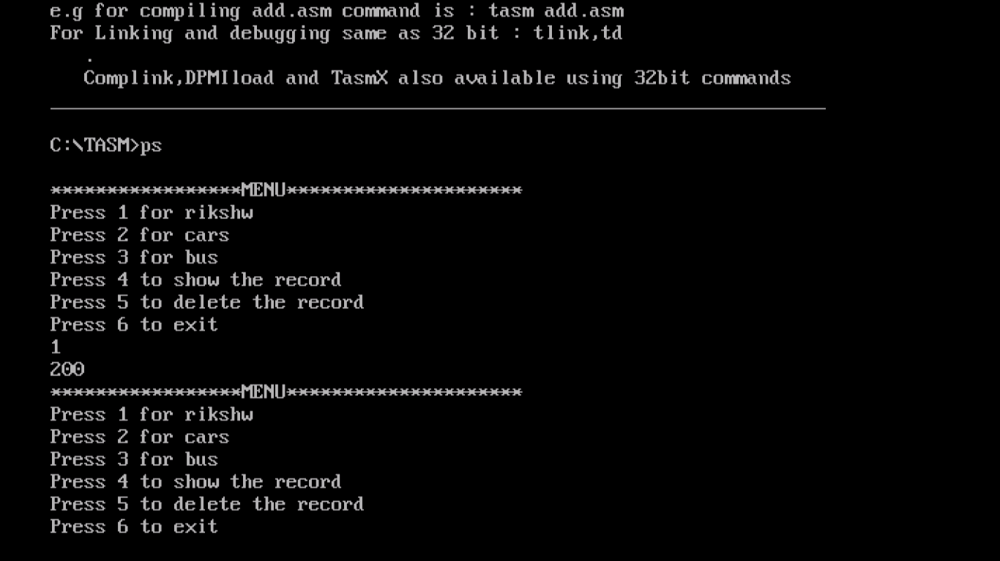

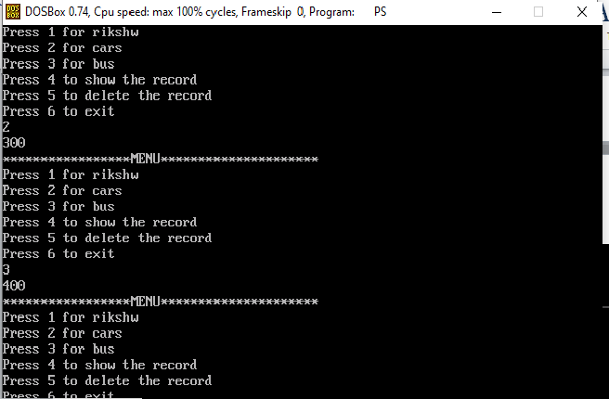

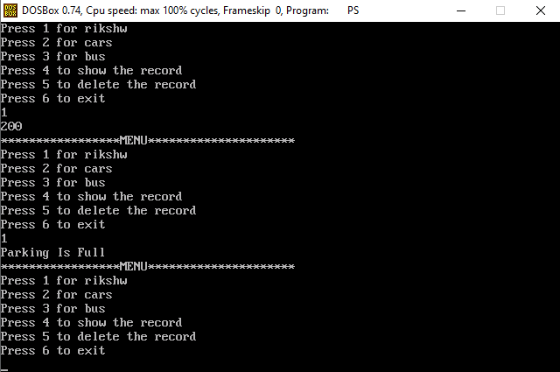

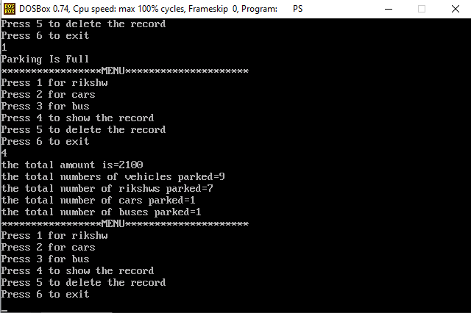

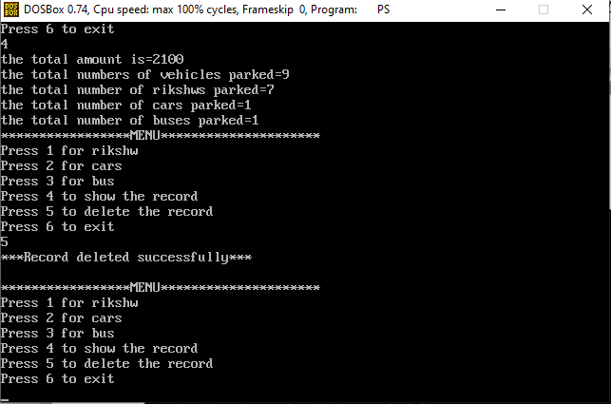

1. **PROJECT CODE:**

dosseg

.model small

.stack 100h

.data

menu db '*****************MENU*********************$'

menu1 db 'Press 1 for rikshw$'

menu2 db 'Press 2 for cars$'

menu3 db 'Press 3 for bus$'

menu4 db 'Press 4 to show the record$'

menu5 db 'Press 5 to delete the record$'

menu6 db 'Press 6 to exit$'

msg1 db 'Parking Is Full$'

msg2 db 'Wrong input$'

msg3 db 'car$'

msg4 db 'bus$'

msg5 db 'record$'

msg6 db 'there is more space$'

msg7 db 'the total amount is=$'

msg8 db 'the total numbers of vehicles parked=$'

msg9 db 'the total number of rikshws parked=$'

msg10 db 'the total number of cars parked=$'

msg11 db 'the total number of buses parked=$'

msg12 db '***Record deleted successfully***$'

amount dw 0

count dw '0'

am1 dw ?

am2 dw ?

am3 dw ?

r dw '0'

c db '0'

b db '0'

.code

main proc

mov ax,@data

mov ds,ax

while_:

;Menu

mov dx,10

mov ah,2

int 21h

mov dx,13

mov ah,2

int 21h

mov dx,offset menu

mov ah,9

int 21h

mov dx,10

mov ah,2

int 21h

mov dx,13

mov ah,2

int 21h

mov dx,offset menu1

mov ah,9

int 21h

mov dx,10

mov ah,2

int 21h

mov dx,13

mov ah,2

int 21h

mov dx,offset menu2

mov ah,9

int 21h

mov dx,10

mov ah,2

int 21h

mov dx,13

mov ah,2

int 21h

mov dx,offset menu3

mov ah,9

int 21h

mov dx,10

mov ah,2

int 21h

mov dx,13

mov ah,2

int 21h

mov dx,offset menu4

mov ah,9

int 21h

mov dx,10

mov ah,2

int 21h

mov dx,13

mov ah,2

int 21h

mov dx,offset menu5

mov ah,9

int 21h

mov dx,10

mov ah,2

int 21h

mov dx,13

mov ah,2

int 21h

mov dx,offset menu6

mov ah,9

int 21h

mov dx,10

mov ah,2

int 21h

mov dx,13

mov ah,2

int 21h

;userinput

mov ah,1

int 21h

mov bl,al

mov dx,10

mov ah,2

int 21h

mov dx,13

mov ah,2

int 21h

;now compare

mov al,bl

cmp al,'1'

je rikshw

cmp al,'2'

je car

cmp al,'3'

je bus

cmp al,'4'

je rec

cmp al,'5'

je del

cmp al,'6'

je end_

mov dx,offset msg2

mov ah,9

int 21h

mov dx,10

mov ah,2

int 21h

mov dx,13

mov ah,2

int 21h

jmp while_

rikshw:

call rikshaw

car:

call caar

rec:

call recrd

del:

call delt

bus:

call buss

end_:

mov ah,4ch

int 21h

main endp

rikshaw proc

cmp count,'8'

jle rikshw1

mov dx,offset msg1

mov ah,9

int 21h

jmp while_

jmp end_

rikshw1:

mov ax,200

add amount, ax

mov dx,0 ; remainder is 0

mov bx,10

mov cx,0

l2:

div bx

push dx

mov dx,0

mov ah,0

inc cx

cmp ax,0

jne l2

l3:

pop dx

add dx,48

mov ah,2

int 21h

loop l3

inc count

;mov dx,count

inc r

jmp while_

jmp end_

caar proc

cmp count,'8'

jle car1

mov dx,offset msg1

mov ah,9

int 21h

jmp while_

jmp end_

car1:

mov ax,300

add amount, ax

mov dx,0

mov bx,10

mov cx,0

l22:

div bx

push dx

mov dx,0

mov ah,0

inc cx

cmp ax,0

jne l22

l33:

pop dx

add dx,48

mov ah,2

int 21h

loop l33

;mov am2,amount

inc count

inc c

jmp while_

jmp end_

buss proc

cmp count,'8'

jle bus1

mov dx,offset msg1

mov ah,9

int 21h

jmp while_

jmp end_

bus1:

mov ax,400

add amount, ax

mov dx,0

mov bx,10

mov cx,0

l222:

div bx

push dx

mov dx,0

mov ah,0

inc cx

cmp ax,0

jne l222

l333:

pop dx

add dx,48

mov ah,2

int 21h

loop l333

;mov am3,amount

inc count

inc b

jmp while_

jmp end_

recrd proc

mov dx,offset msg7

mov ah,9

int 21h

; print here the whole amount

mov ax, amount

mov dx,0

mov bx,10

mov cx,0

totalpush:

div bx

push dx

mov dx,0

; mov ah,0

inc cx

cmp ax,0

jne totalpush

totalprint:

pop dx

add dx,48

mov ah,2

int 21h

loop totalprint

mov dx,10

mov ah,2

int 21h

mov dx,13

mov ah,2

int 21h

mov dx,offset msg8

mov ah,9

int 21h

mov dx,count

mov ah,2

int 21h

mov dx,10

mov ah,2

int 21h

mov dx,13

mov ah,2

int 21h

mov dx,offset msg9

mov ah,9

int 21h

mov dx,r

mov ah,2

int 21h

mov dx,10

mov ah,2

int 21h

mov dx,13

mov ah,2

int 21h

mov dx,offset msg10

mov ah,9

int 21h

mov dl,c

mov ah,2

int 21h

mov dx,10

mov ah,2

int 21h

mov dx,13

mov ah,2

int 21h

mov dx,offset msg11

mov ah,9

int 21h

mov dl,b

mov ah,2

int 21h

jmp while_

jmp end_

delt proc

mov r,'0'

mov c,'0'

mov b,'0'

mov amount,0

;sub amount,48

mov count,'0'

mov dx,offset msg12

mov ah,9

int 21h

mov dx,10

mov ah,2

int 21h

mov dx,13

mov ah,2

int 21h

jmp while_

jmp end_

end main

1. **PROJECT SUMMARY**

The objective of this project is to design t a Parking Management System (SMS) which would help in the storing a records of vehicles.

1. **CONCLUSION:**

This is the modern age. Many people have vehicles. Vehicle is now a basic need. Every place is under the process of urbanization. There are many corporate offices and shopping centers etc. There are many recreational places where people used to go for refreshment. So, all these places need a parking space where people can park their vehicles safely and easily. Every parking area needs a system that records the detail of vehicles to give the facility. These systems might be computerized or non-computerized. With the help of computerized system we can deliver a good service to customer who wants to park their vehicle into the any organization’s premises.

# 9) REFERENCES:

Denis E.E & Wixom B. (2000): Application Development

Harsh B.S (2009): Parking Management Systems

Kenneth F.A and Laudon J.B (2001): Parking Management Systems